Swiss Interfaith Women
Esther R. Suter, President, Dornacherstrasse 281, 4053 Basel, Switzerland
0041 (0) 61 331 1725, e_r_suter@hotmail.com

Project «Religion and Art» 2020
Youth Camp August 10 – 22nd, 2020

The association “Swiss Interfaith Women” offers for 2020 for the second time an international, intercultural and interfaith youth camp within “Religion and Art”. The project goes together with the artist Gabriella Affolter and her Atelier “Kreativwerkstatt” in Solothurn. She is Vice-President of Swiss Interfaith Women, who are committed to human rights, gender-justice, religious freedom as well as against discrimination and racism. SIW is a member organization of the International Association of Liberal Religious Women (1910), www.ialrw.org

Young women (between 18 and 30 years old) living in Switzerland, Spain, Greece and Israel will participate in the Youth Camp. They work together with intercultural and interfaith text images, oriented at the subject of Peace, Shalom, Paz (e.g. Peace with Nature). They bring along their own short texts, poems from authors and texts from Holy Scriptures of their country and religion, oriented on Peace. They use them for creating text images. No special formation is needed but simply the joy of expressing in art. Some may bring along a formation in Fine Arts and will have a chance to deepen their experience and skills. -

Three specialists in art and religion are invited, among them the artist of the Taizé Community (France), Brother Marc, the Swiss-Afghan Muslima Sozan Mohebbi-Rasuli, responsible for a dialogue program in the Forum für Zeitfragen in Basel, and the artist and psychotherapist Dr. Ruth Herzka, author and Jewish activist in Basel. They will give insights from their background.
In various exchange groups, in living together, cooking together “national” or “religious” meals the young women experience different cultures, religions, political and social backgrounds, and learn how to adapt to them. They discover differences and similarities to express in art which will bring them together to form a dynamic group. The art work will be exhibited in the Church Center Zwinglihaus in Basel, Vernissage August 20th evening at 5 pm.

From each country four young women (18 to 30) and a group leader (25 to 40) can participate. Program (material), food and stay (Pfadiheim/scout house) are free, financed by Swiss Interfaith Women, but so far no travel expenses are refunded. Some English knowledge is necessary for exchange and contacts. Enthusiasm to get to know other cultures and religions and to express in art is all you have to bring with you. Any nationality or religion is welcome, at the condition that the applicant lives in the respective country. They will at the end receive a certificate for their participation in the youth exchange program.
For further information please contact:

Rev. Esther R. Suter, Switzerland, President SIW, Vice-President IALRW and project leader, phone 0041 (0) 61 331 1725; e_r_suter@hotmail.com

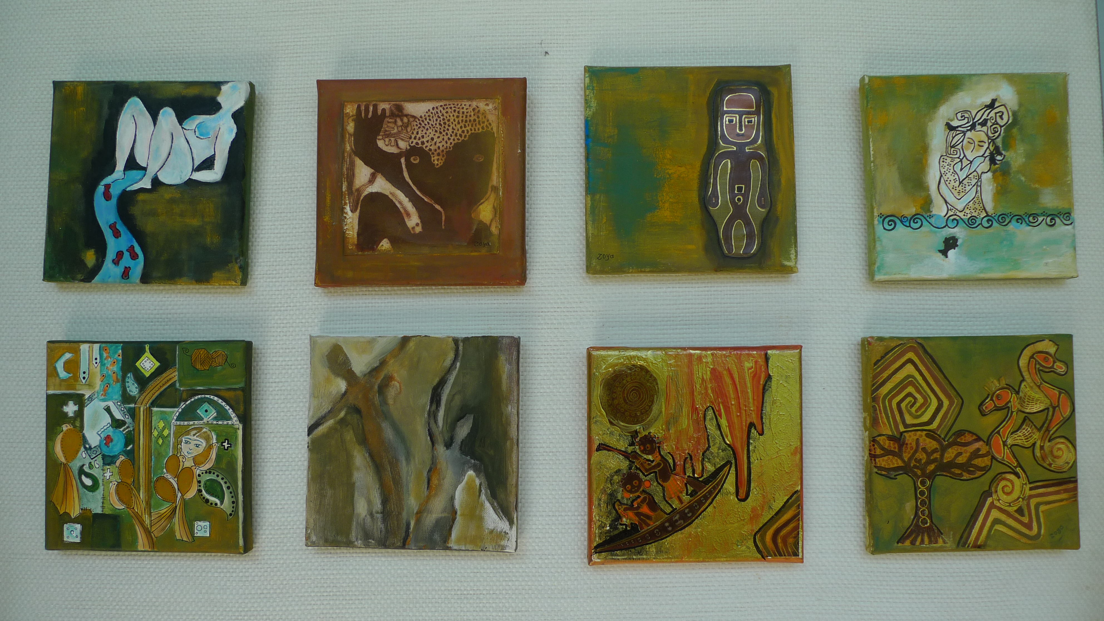

Text Images created in 2019 by a refugee woman from Iran

