Program of Activities by CiCi Group & IALRW
FY 2014 – 2018
Greetings to ALL,

Due to the unceasing effort to give back to the society the CiCi Group, The Youth Volunteers & IALRW embarked on some projects and programs which they are of help to the people. Those projects primarily aimed to let the community know that the Team and some segment of the society does care, feel their pain and somehow wish to alleviate or lessen their agony. Listed below are some of the projects and programs the Team and the dedicated youth volunteers managed to implement.

2014- We C.A.R.E Project for the Street Children of Cotabato City, Maguindanao & Nearby Provinces.
We care stands for Cotabato Affection Relief Effort (C.A.R.E)
We C.A.R.E Project
for
the Street Children
of Cotabato in April 2014
OBJECTIVE
The objective of Project we-C.A.R.E. is to interact and engage the street children to show that people love and care for them. The engagement is done through varied activities that are fun and educational. It is through these activities that we can make them be aware of their own potential. Also, their interaction and engagement with the volunteers will expose them to the people outside their area. It is through this contact time that it is hoped the children will be inspired to be the best that they can be and thus develop aspirations for their own future.

Hygiene
- Brushing teeth
- Mass Water Play
- New set of Clothes
- Packed Meals - Breakfast and Lunch
- Story Telling - Its all about values
- Games - Gross motor skills and creative thinking
- Origami
- Skill to create forms from paper
- Listening to instructions
- Observation skills

- Drawing Contest
  - Self Expression
  - Trigger the mind to consciously think of aspirations and hopes for the future
  - Discover their own talents
- Goodie Bag
- Local Youth Volunteers

- First step to be empowered in helping the community
- 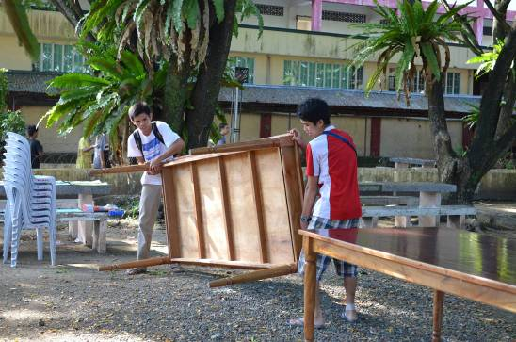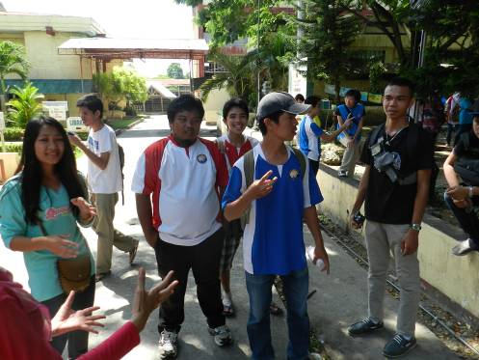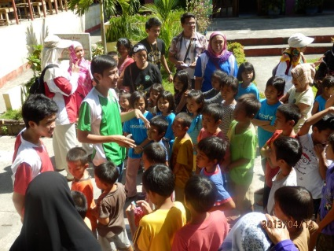
- 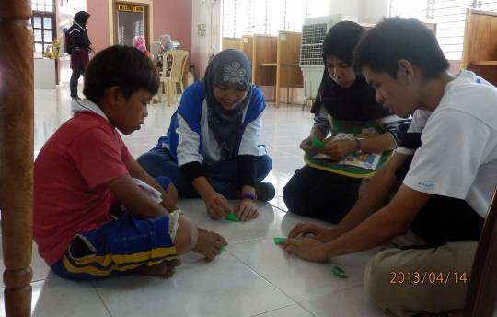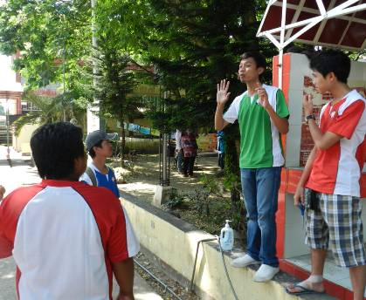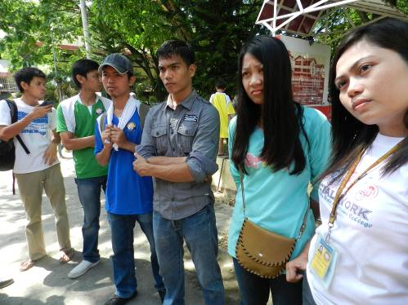
July 2015 – Small scale project Give school supplies to one of the Orphanage for Boys as well as deserving poor students’
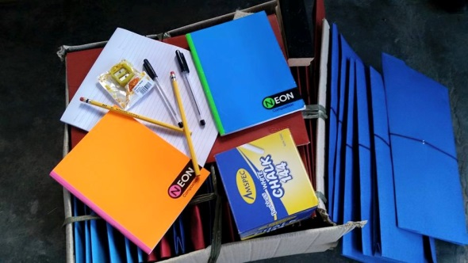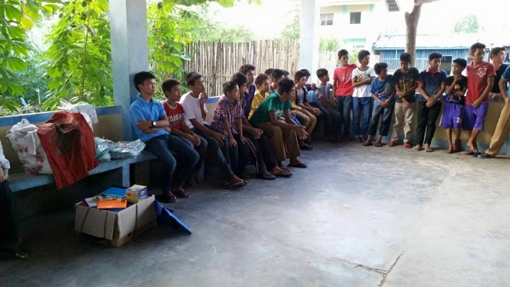
September 2015 -– Charity programs and Relief operations program
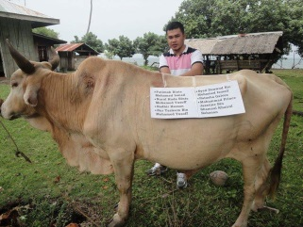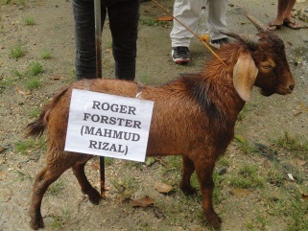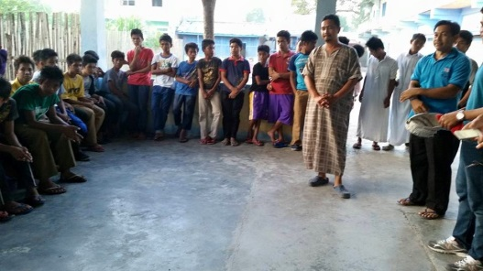
Annual Distribution of slaughtered meat to poor people and orphanages.
July 2016 – Together with the Team members and volunteers distributed T-shirts to the Ibn Aytam Orpahanges
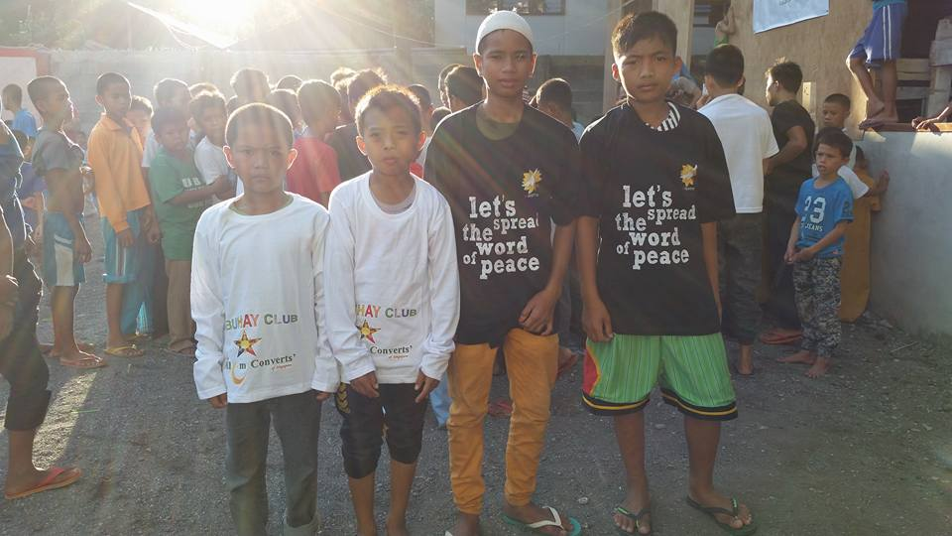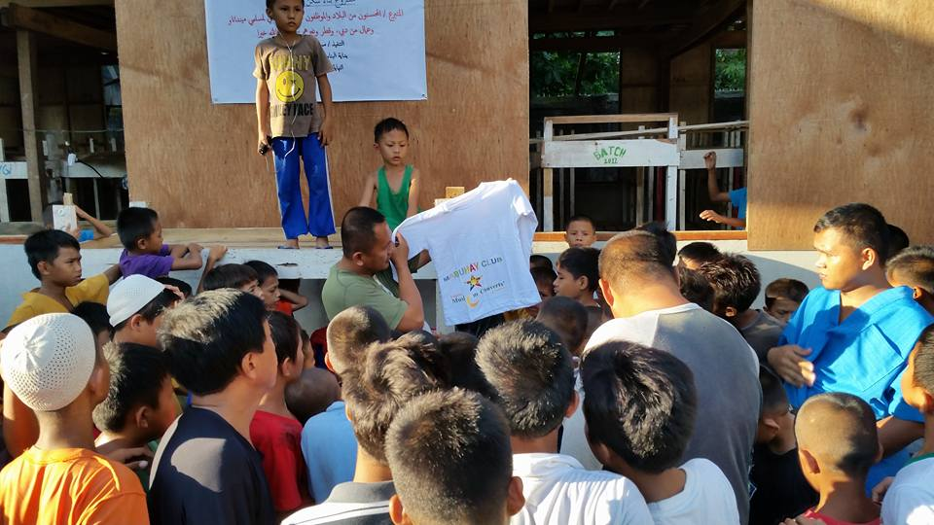
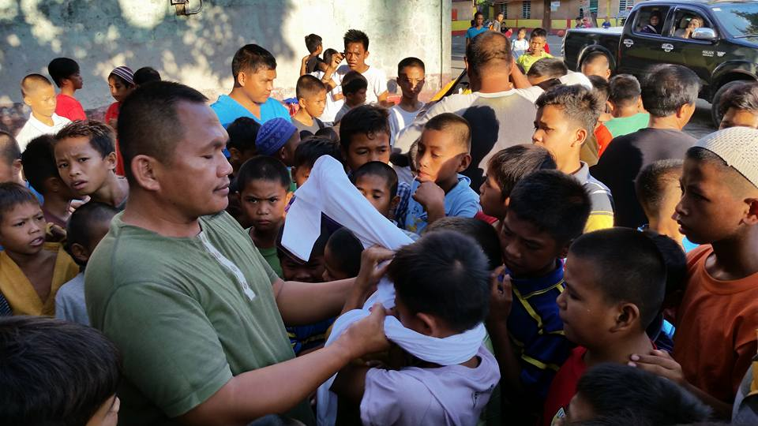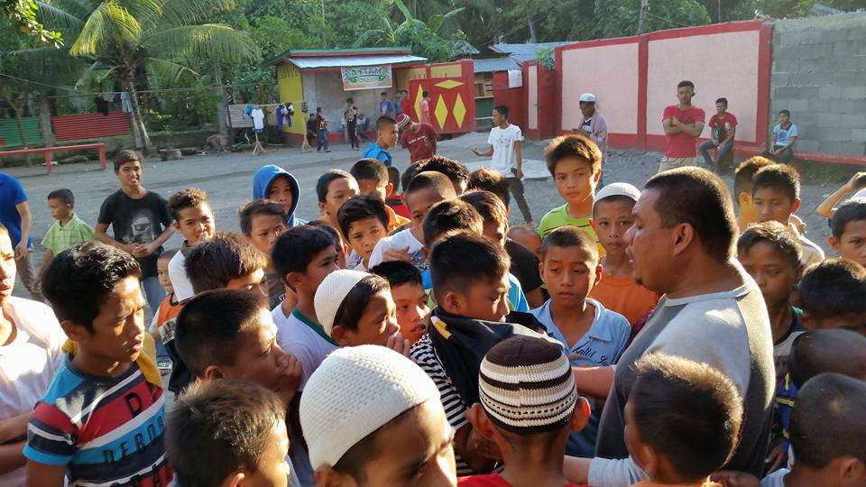
September 2016 – Qorban was held in September 2016. Below shows the recipient of the Meat.
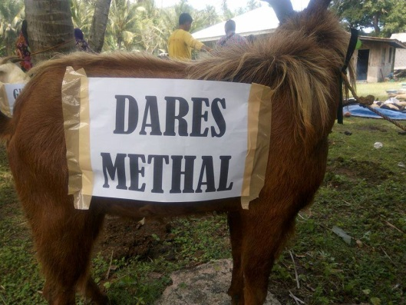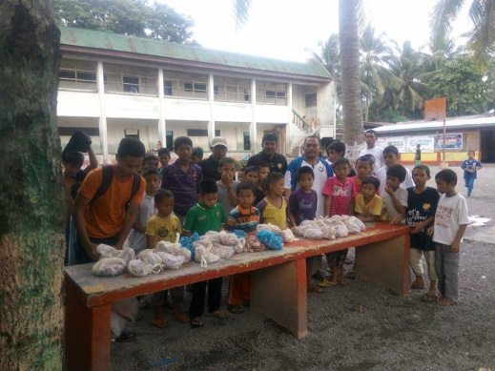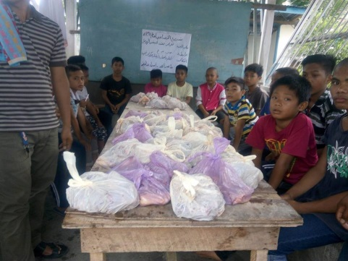
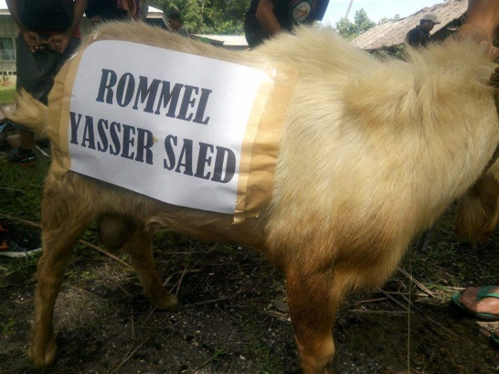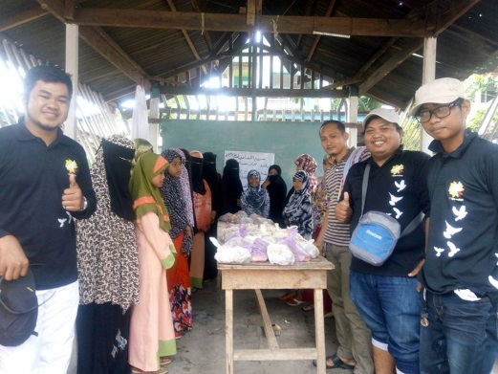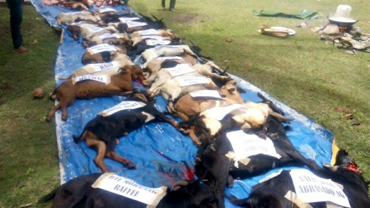

February 2017 - A joint effort between our Team and the Cotabato High School Batch 1976 to give back to the community. Together we distributed School supplies to the school located in Timako Primary School in Dinaig, Maguindanao Province. The do not have enough classroom. We also sponsored a feeding session. Our volunteers kindly cooked the food we offered to the students’
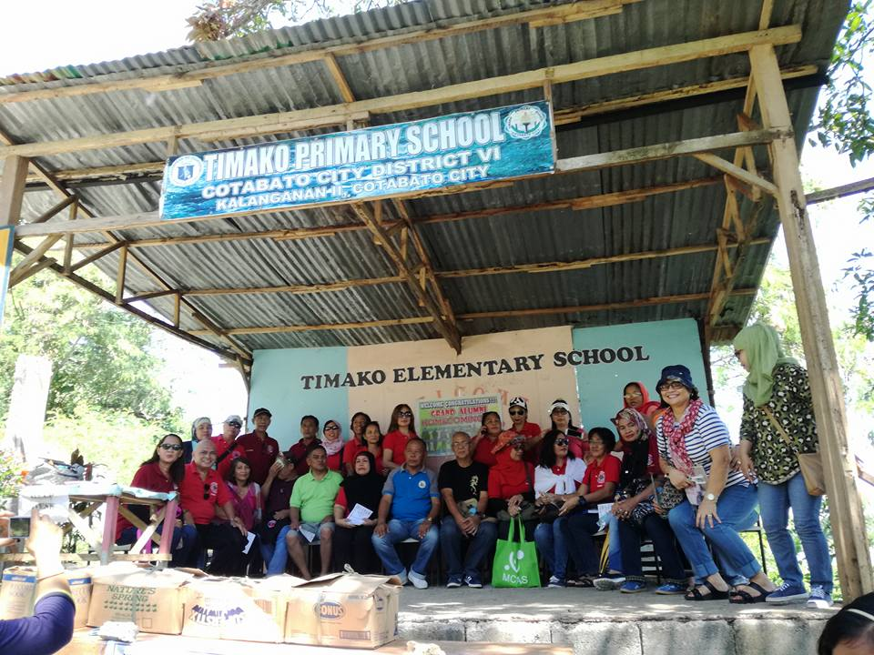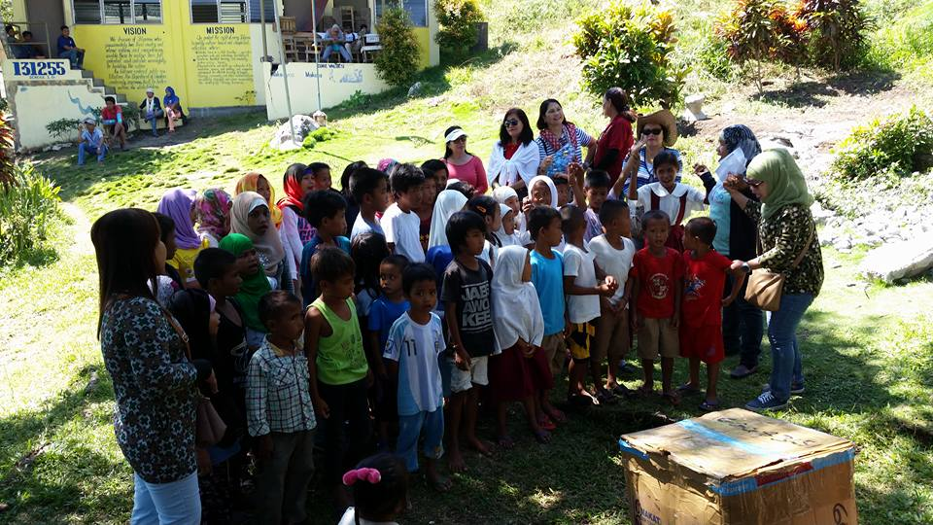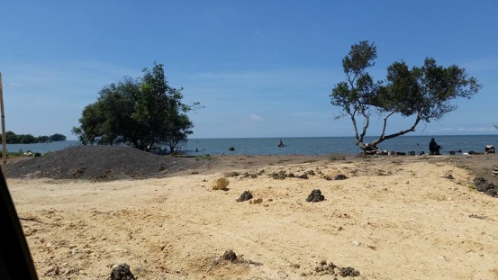
03 & 04 February, 2017 – Distributed goodies, clothing, 3 sacks of Rice (55 Kilos each)
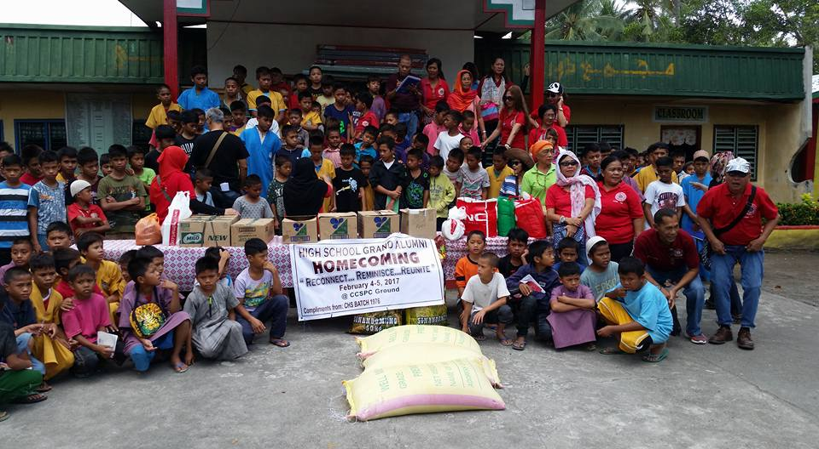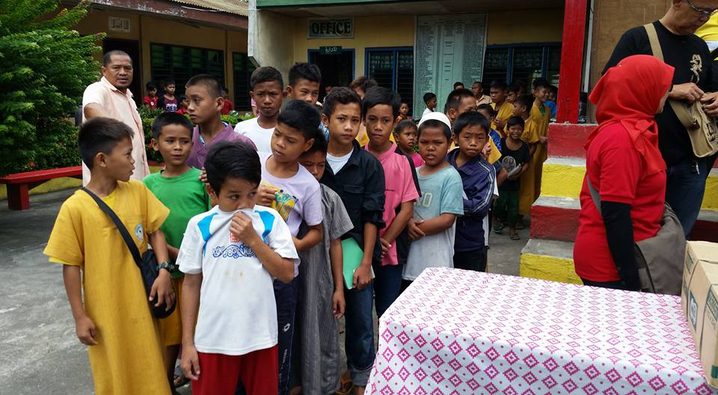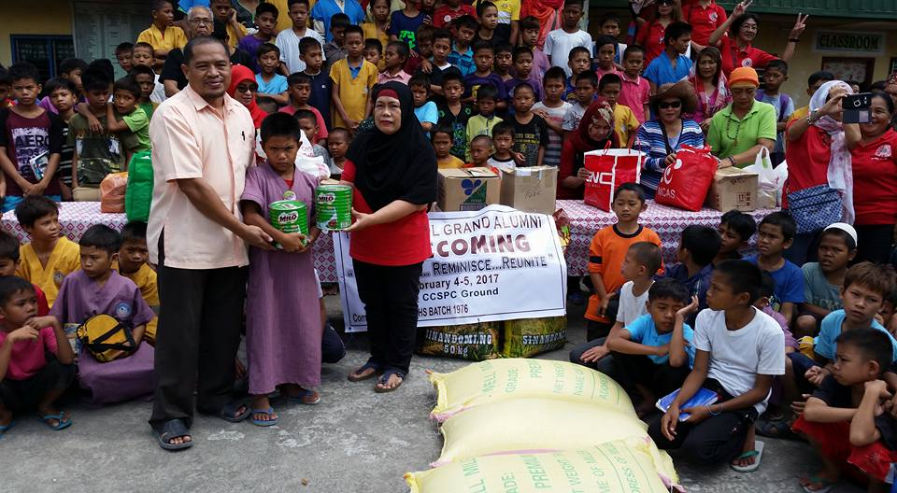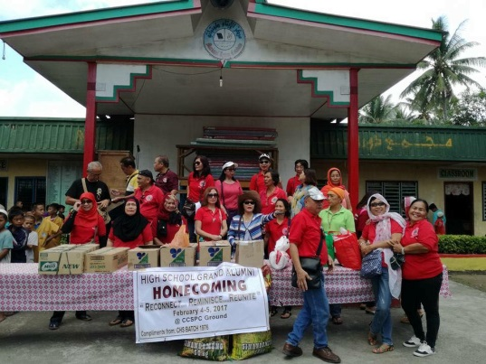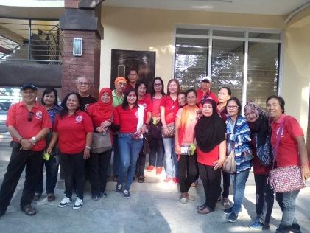

02 July 2017 – Relief Operations Programmes to the Barangay Tambak, SK. Also Distributed goodies and used clothings to the residents’ of Barangay Kadigasan, Midsayap, North Cotabato.
Distributed Financial Assistance to the residents’ of Barangay Lower Olandang, Midsayap, North Cotabato.
07 July, 2017 – Committee brainstorming on our course of Action
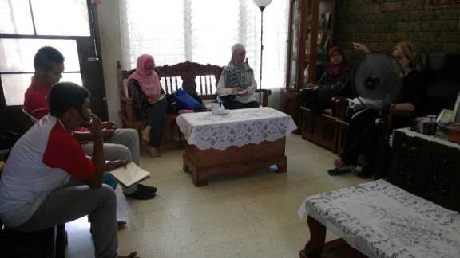
08 July, 2017 – Celebrated Eid ul Fitr with the Orphans – Bringing The Spirit of Eid ul Fitr To The Orphanages at Aytan Orphanage in Gang, Sultan Kudarat Philippines – Sponsored by CiCi Members, Supporters & IALRW
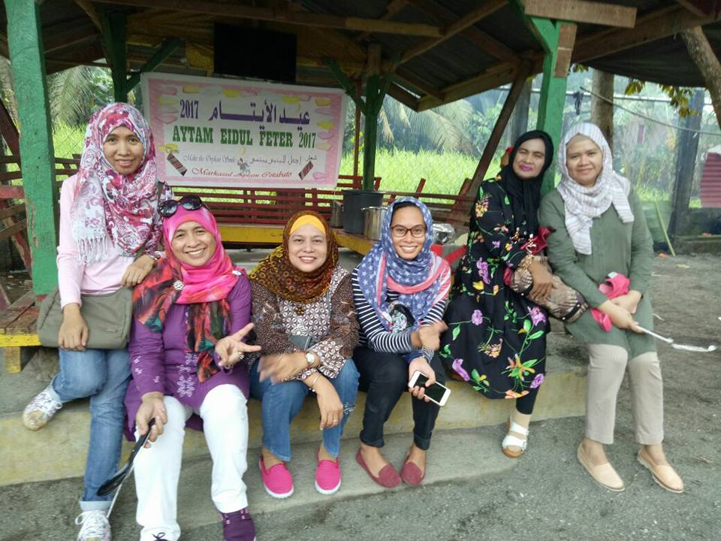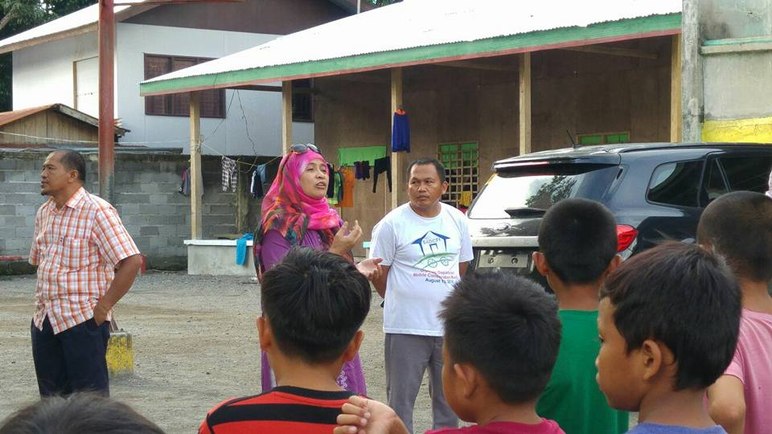
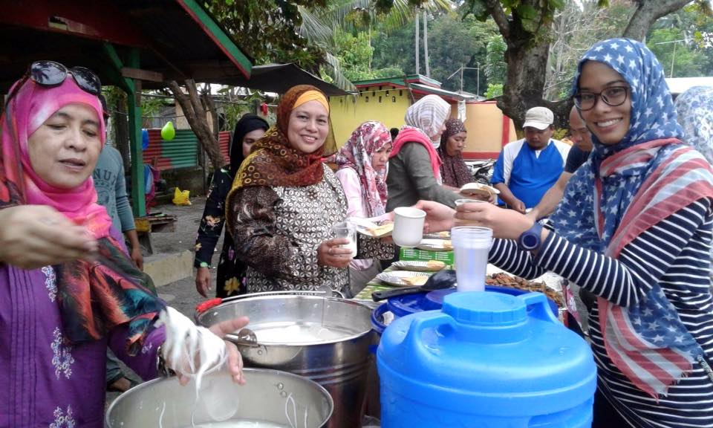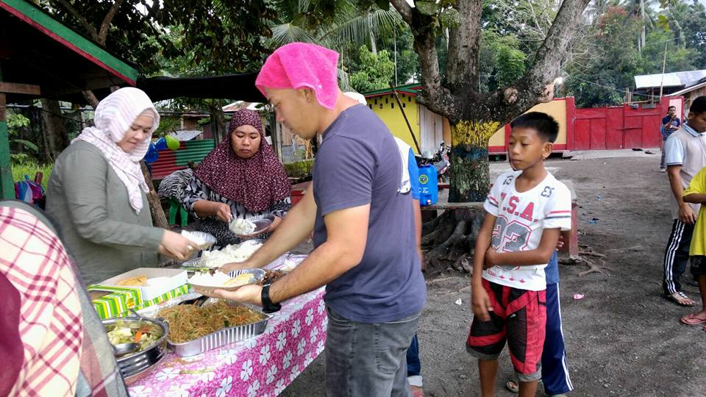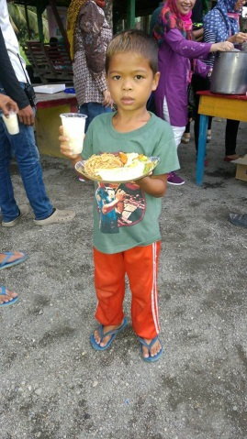

09 July, 2017 – Training the Trainers’ Workshop. It is a whole day workshop attended by student leaders from different schools held at Cotabato City State Polytechnic College Audio Visual Room. Sis Suzana Aboo Bakar was the Trainer.
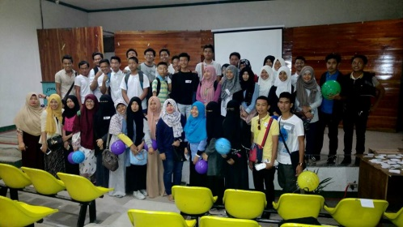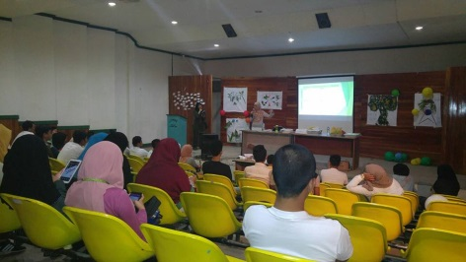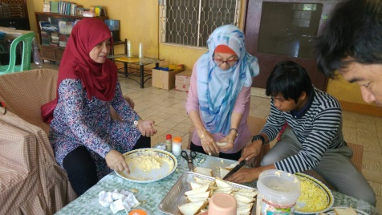
10 July, 2017 - Sharing Session with students and campus leaders of Sultan Kudarat Islamic Academy from 9 am – 1030 am
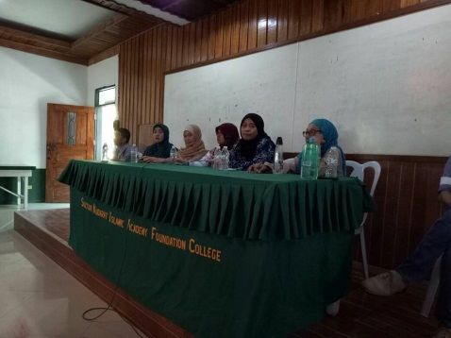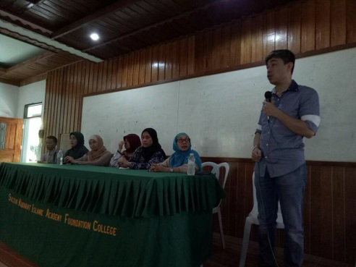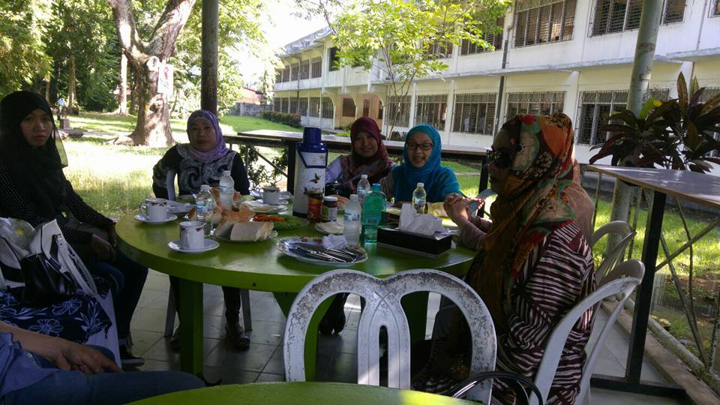

10 July 2017 – Charity Project & Relief Operations program in Barangay Nabalawag and Kadigasan, Midsayap, North Cotabato/Cotabato Province. The residents’ of these 2 baranggays were severely hit by the floods.

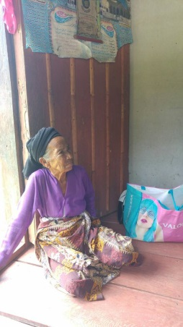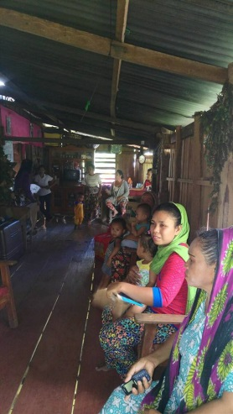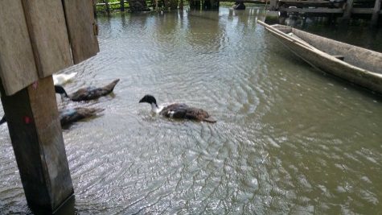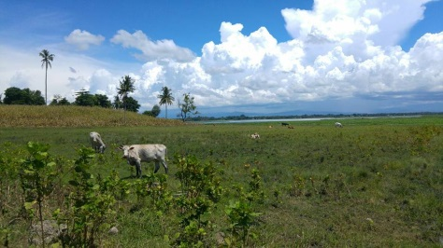

11July, 2017 – Breakfast with Volunteers
Acryllic Art Drawing by Sis Momtaz Hj Akib held at SKIA Canteen and Social Hall
Lunch
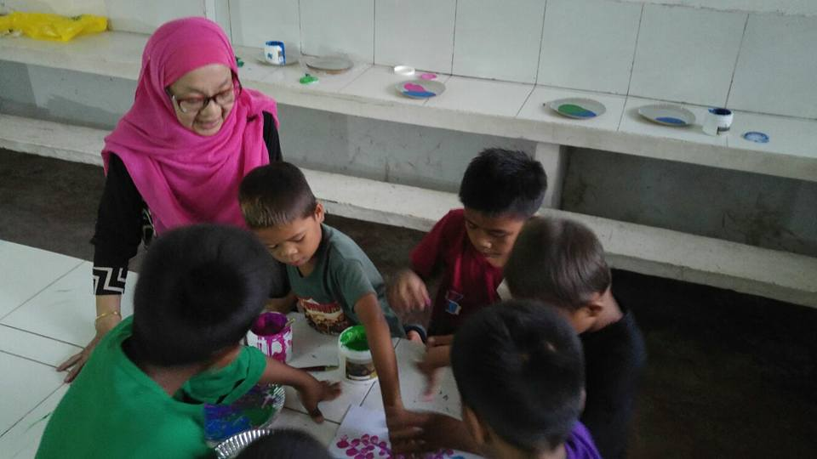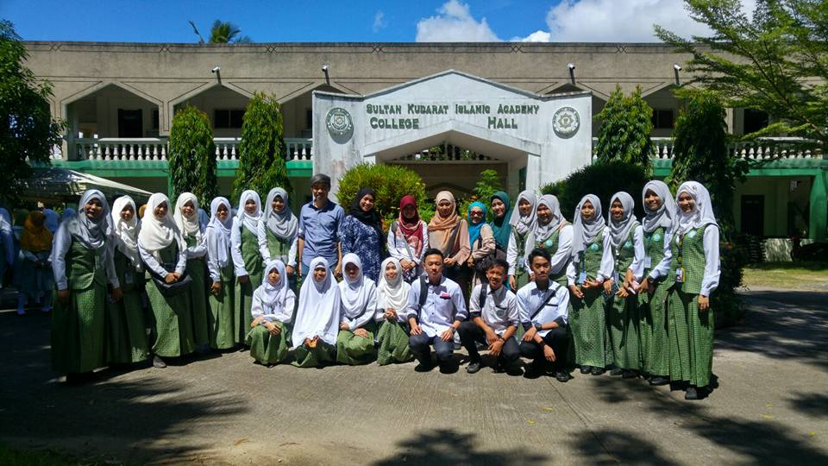

11 July, 2017 - 2 pm onwards Training the Trainers Workshops. This is to train the teachers’ for continuity of the project

12 July, 2017 - Left for Doroluman, Magpet, North Cotabato – Cotabato Foundation & College of Science & Technology
We were warmly received by the Management headed by the Vice President named Mrs Marrieta Cayabas. We also seek their clearance to distribute goodies to the orphans in the campus comprises of natives, Muslims and non-Muslims. The relationship of the teachers and the locals are harmonious. The team and I distributed towels, Soap, Biscuits, Juices, Mineral and some cookies from Singapore.
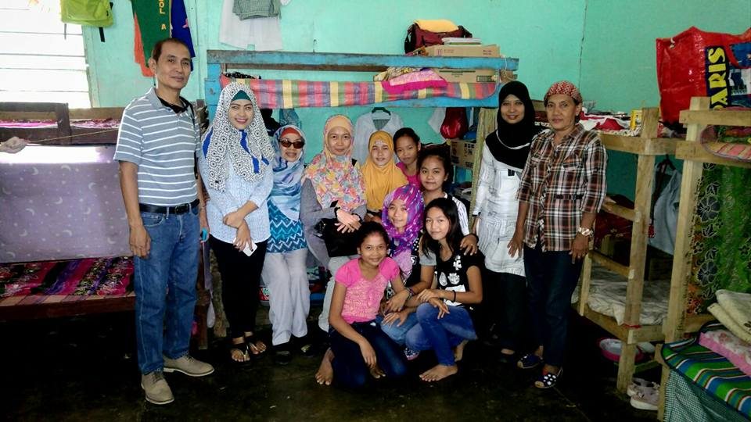
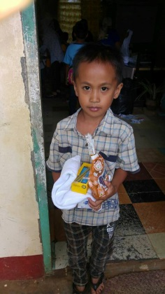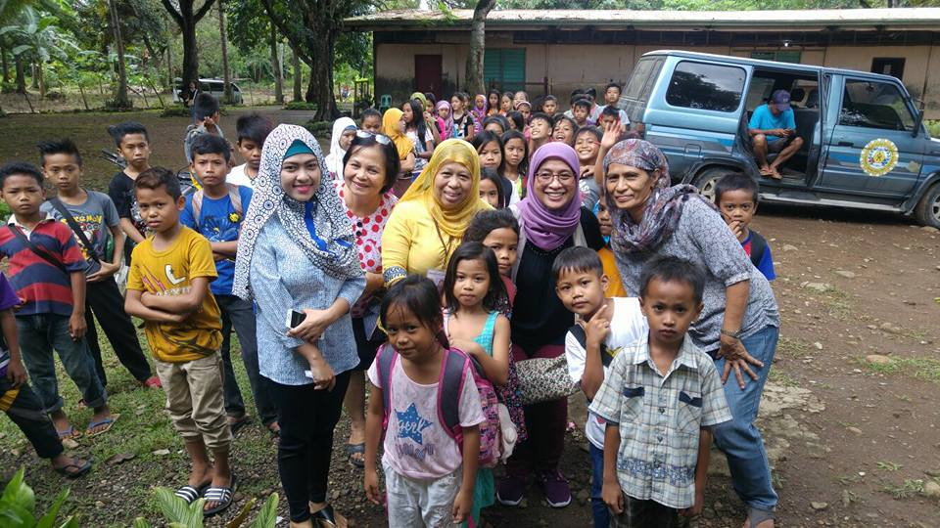
12 & 13 July, 2017 The team visited Davao City.
14 July, 2017- Back in Cotabato City Visited Masjid of Sultan Hasanul Bolkiah, Masjid El El Abpi and other places of great interest for future project.
08 August 2017- Humanitarian Help i.e. 4 to 5 of LBC Extra large Boxes to assist the the victims of the Maute Crisis in Marawi City by our volunteers
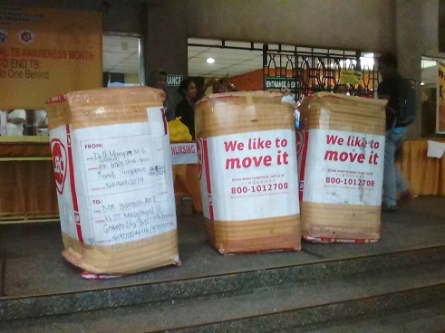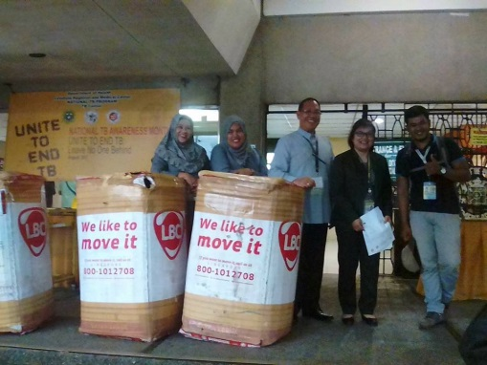
03 September, 2017- Slaughtered 3 Cows and 20 Goats in commemoration of the Day of Sacrifice – Eid ul Adha. The meat were distributed to the less fortunate residents of the nearby barangays, 3 orphanages and poor students’
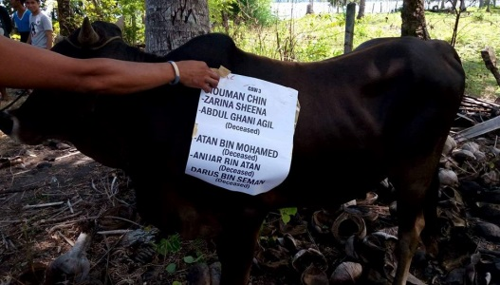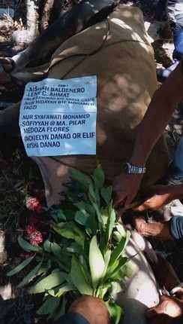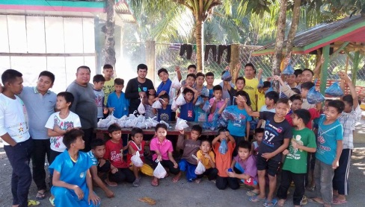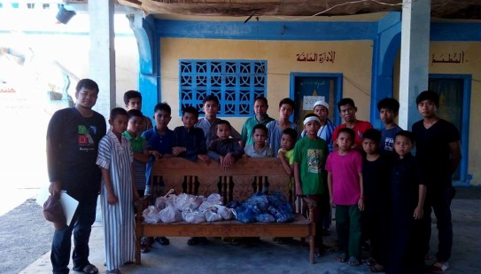
Students’ Sponsorship – Commenced in 2009 till the present – CiCi Group with the help of some friends still sponsored some deserving but hardworking and intelligent students’ who wish to pursue tertiary education. Some of our volunteers are part of our sponsorship.\
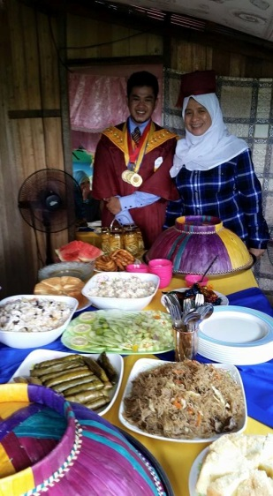One of the students we sponsored. He is a licensed social worker now.

Sending of boxes to Mindanao is an on-going project by CiCi Group & IALRW group. This also started since 2007.

2018 – 2023 – Planning to build a humble Centre/ Classrooms and targeting hopefully to complete by 2023. The premises is owned by one of our member.
